**DEEP LEARNING LAB 1 REPORT**

**TASK:**

To implement logistic regression with a different and new data set and show the results in a graphical way on Tensor Board. Also, find the results by changing the hyperparameter and make a comparison report and find the references.

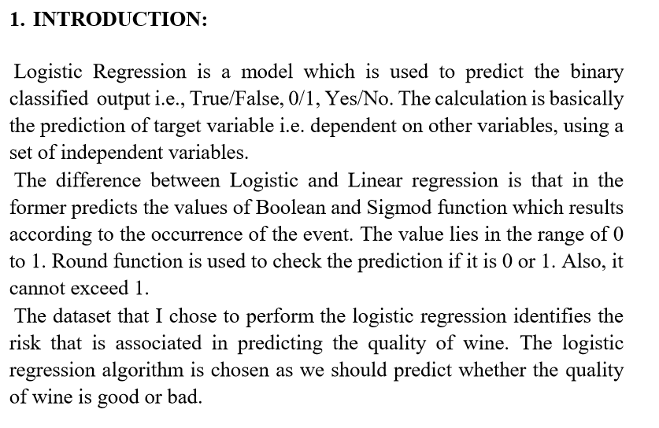

**2. OBJECTIVES:**

The main objective of this logistic regression model is to check if the model is able to predict the wine quality. This is done by the use of independent variables. Cost or loss represents how far is our model from the desired output. This is determined by cross entropy function. We will try to minimize this cross entropy for better results using gradient descent optimizer. By going through 25 training epochs the data has been trained. And model will be tested, and accuracy is predicted.

**3. APPROACH:**

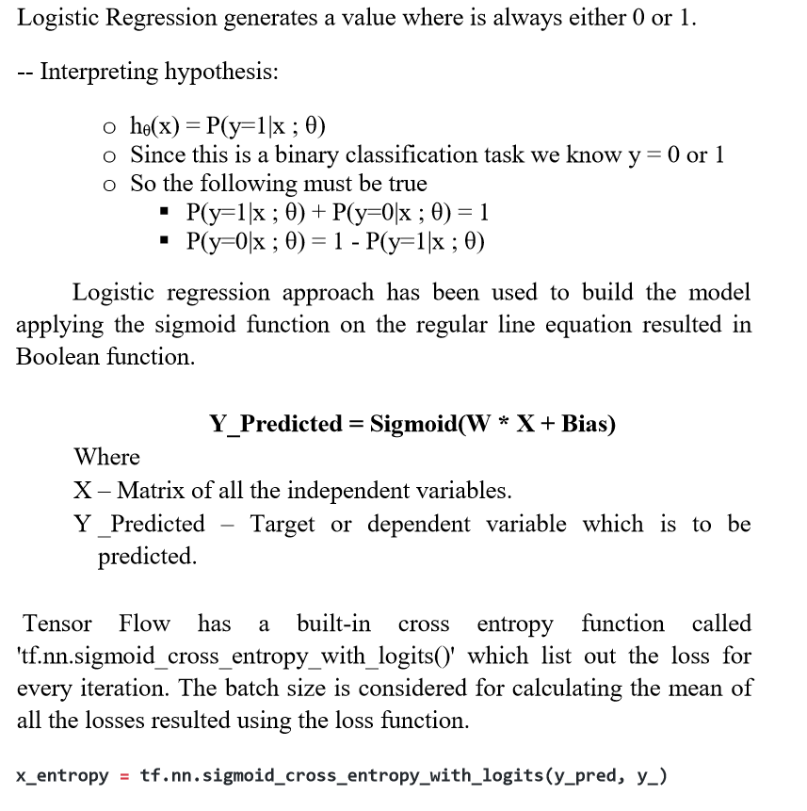

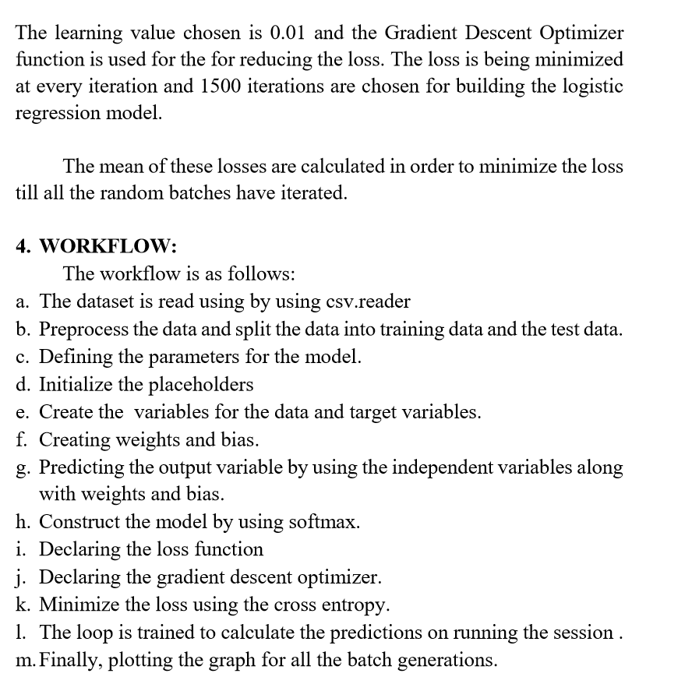

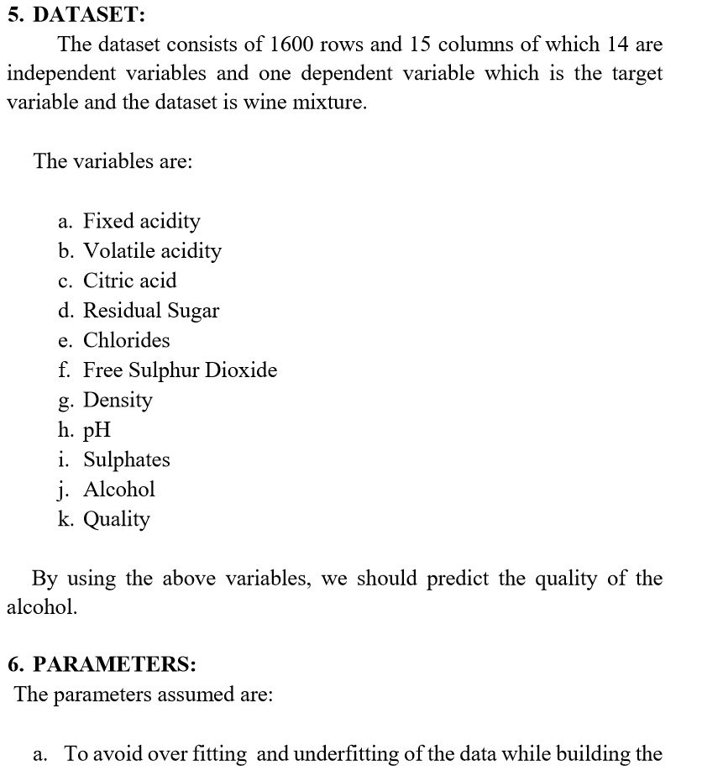

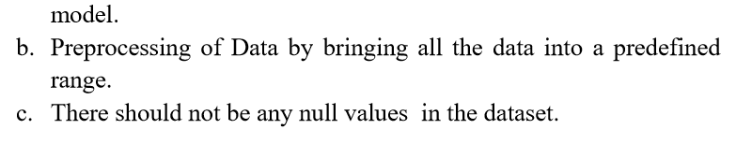

**7. EVALUATION & DISCUSSION:**

**Output screenshots:**

